Assignment-4
NAME: MANDADI DEESHWARI REDDY
HALL TICKET NO:2503B05104
Question:
Write a C++ program to implement Hamming Code for error detection and correction.
Requirements:
- Accept a binary data string as input.
- Determine the number of redundant bits required.
- Insert the redundant bits into appropriate positions (1, 2, 4, 8, …).
- Calculate and set the parity bits using even parity logic.
- Display the final data packet (data bits + redundant bits) to be transmitted.
- Simulate the receiver side to:
  - Recalculate parity bits.
  - Detect if there is any single-bit error.
  - Display the position of the erroneous bit or confirm no error if data is correct.

CODE: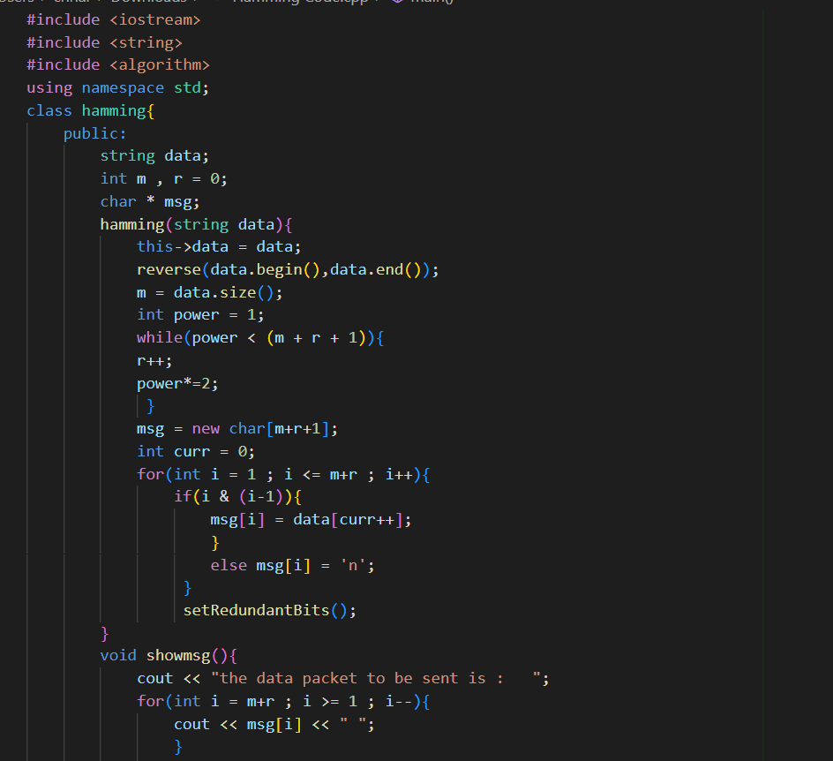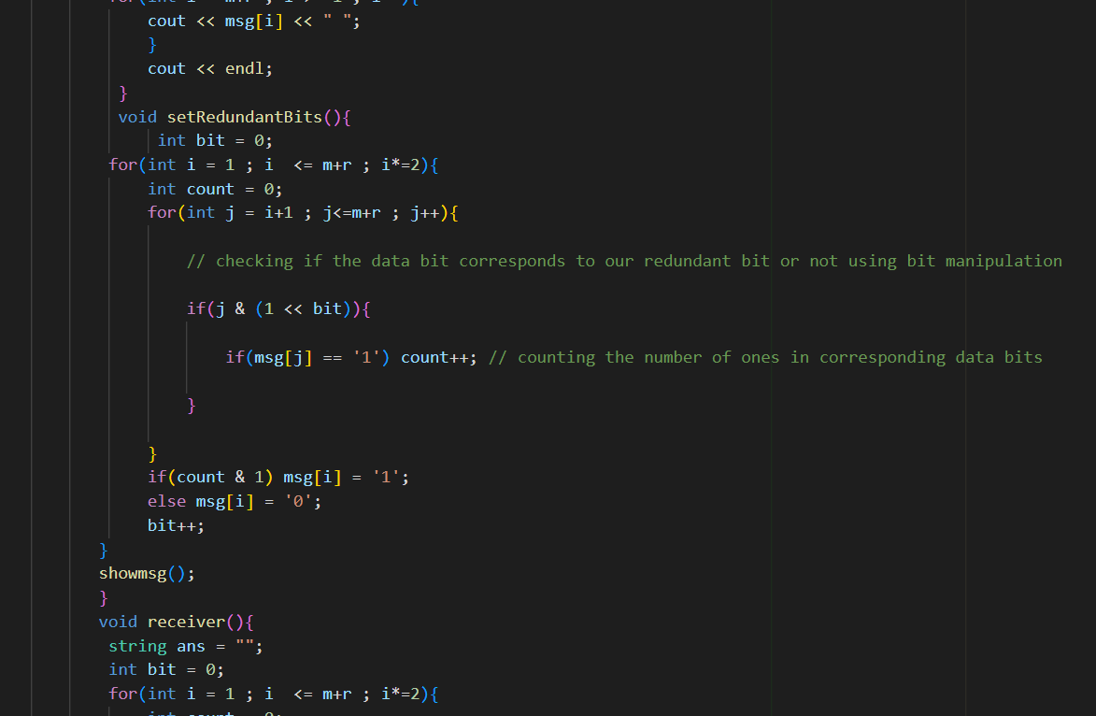
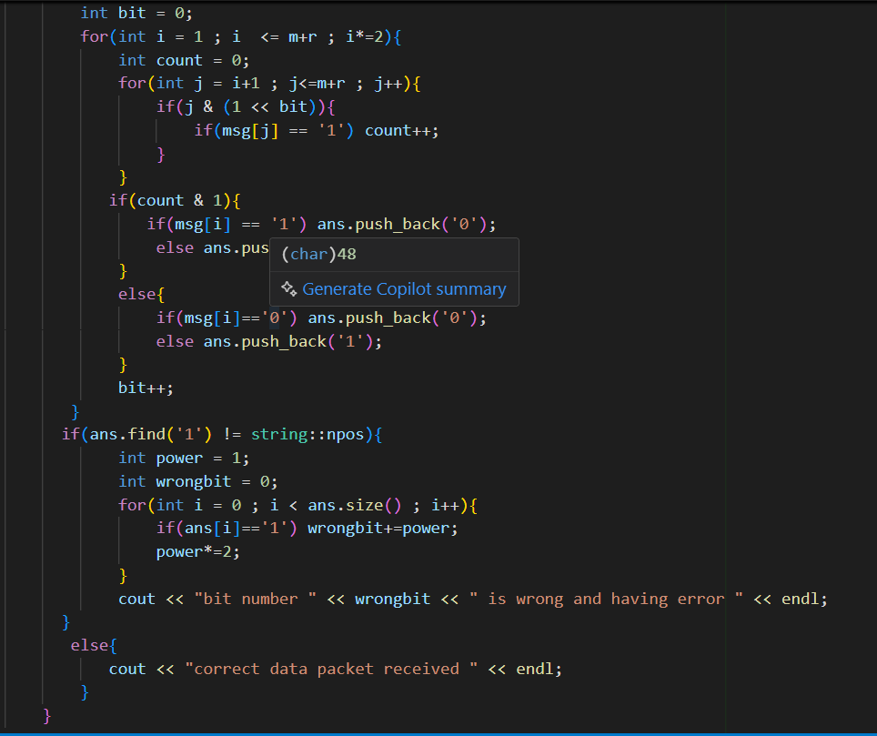
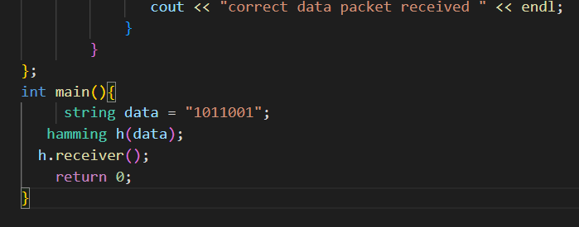

OUTPUT:
